$$Decision Tree:$$

$$The main goal : Find the root node$$

$$1) Information gain: Entropy$$

$$Step-1:Calculate Individual entropy$$

$$Step-2:Calculate total entropy$$

$$Step-3:Calculate gain=H_{Total}-H_{feature}=step_{2}-step_{1}$$

$$Step-4:Split information of each feature$$

$$Step-5:Gain ratio=\frac{Gain}{Split information}=\frac{step3}{step4}$$

$$2) Gini index:$$

$Information gain will talk about postive way:Clarity in information$

$Gini index will give the idea about impurity , how much a feature has impure$

$How a data sample is misclassified$

$For example, assume that a person does not have cancer$

$If model says as cancer : wrong prediction$

$This is misclassified , It is impure$

$The behaviour of root node is less impurity, Gini index shoul low$

$Gini=1-\sum_{i=1}^{n}{p_{i}^{2}}$

$$NOTE: Gini uses at a Time only Binary split$$

$$For example income feature:$$

|  |  |  |
| --- | --- | --- |
| $$Id$$ | $$income$$ | $$Buys a computer$$ |
| $$1$$ | High | No |
| 2 | High | No |
| 3 | High | Yes |
| 4 | Medium | Yes |
| 5 | Low | Yes |
| 6 | Low | No |
| 7 | Low | Yes |
| 8 | Medium | No |
| 9 | Low | Yes |
| 10 | Medium | Yes |
| 11 | Medium | Yes |
| 12 | Medium | Yes |
| 13 | High | Yes |
| 14 | Medium | No |

$$Income divide into 3 splits$$

$High$

$Low$

$Medium$

$$\left\{\right\}, \left\{High\right\},\left\{Low\right\},\left\{Medium\right\},\left\{High,Low\right\},\left\{Low,Medium\right\},\left\{High,Medium\right\},$$

$$\left\{High,Medium,Low\right\}:Power set or Super set$$

$$Under the Gini of income:$$

$Case-1: \left\{High,low\right\} and \{Medium\}$

$$Case-2: \left\{High,medium\right\} and \left\{low\right\}$$

$$Case-3: \left\{low,medium\right\} and \{high\}$$

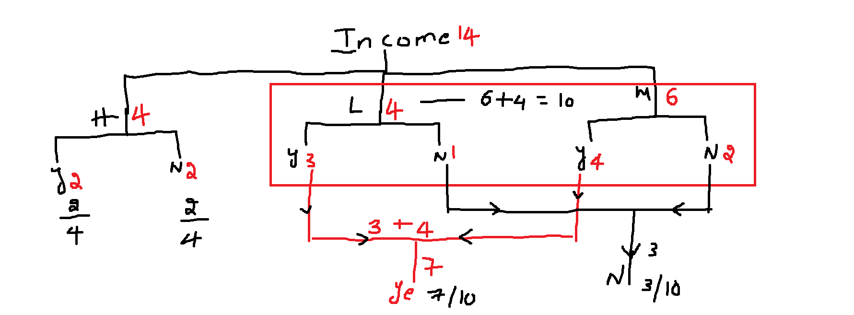

$$Step-1: Calculate total data Gini$$

$$Yes=9 ;No=5$$

$$p\left(yes\right)=\frac{9}{14} p\left(No\right)=\frac{5}{14}$$

$Gini_{data}=1-\sum_{i=1}^{n=2}{p_{i}^{2}}=1-\left[p_{yes}^{2}+p_{no}^{2}\right]$

$1-\left[p_{yes}^{2}+p_{no}^{2}\right]=1-{\left(\frac{9}{14}\right)}^{2}-{\left(\frac{5}{14}\right)}^{2}$

$$Step-2: Calculate total data Gini index of income$$

$Case-1:\left\{Low,medium \right\} vs \{High\}$

$Gini_{income}= w_{lm}*Gini_{lowmedium} + w_{high}* Gini_{high}$

$Gini_{lowmedium}:$

$p\left(yes\right)=\frac{7}{10} p\left(No\right)=\frac{3}{10}$

$1-\left[p_{yes}^{2}+p_{no}^{2}\right]=1-{\left(\frac{7}{10}\right)}^{2}-{\left(\frac{3}{10}\right)}^{2}$

$w_{lm}=\frac{10}{14}$

$Gini_{high}:$

$p\left(yes\right)=\frac{2}{4} p\left(No\right)=\frac{2}{4}$

$1-\left[p_{yes}^{2}+p_{no}^{2}\right]=1-{\left(\frac{2}{4}\right)}^{2}-{\left(\frac{2}{4}\right)}^{2}$

$w_{high}=\frac{4}{14}$

$$Gini_{income}= w_{lm}*Gini_{lowmedium} + w_{high}* Gini_{high}$$

$$Gini_{income_{case1}}= \frac{10}{14}*\left[1-{\left(\frac{7}{10}\right)}^{2}-{\left(\frac{3}{10}\right)}^{2}\right] +\frac{4}{14}*\left[1-{\left(\frac{2}{4}\right)}^{2}-{\left(\frac{2}{4}\right)}^{2}\right]=0.443$$

$$similarly we need to calculate$$

$case-2: \left\{High medium\right\} vs \{Low\}$

$$Gini_{income_{case2}}= w_{hm}*Gini_{highmedium} + w_{high}* Gini_{low}=0.450$$

$$Gini_{income_{case2}}= \frac{10}{14}*\left[1-{\left(\frac{6}{10}\right)}^{2}-{\left(\frac{4}{10}\right)}^{2}\right] +\frac{4}{14}*\left[1-{\left(\frac{3}{4}\right)}^{2}-{\left(\frac{1}{4}\right)}^{2}\right]=0.450$$

$$case-3:\left\{High low\right\} vs \{medium\}$$

$$Gini_{income_{case3}}= w_{hl}*Gini_{higlow} + w_{med}* Gini_{med}=0.458$$

$$Gini_{income_{case3}}= \frac{8}{14}*\left[1-{\left(\frac{5}{8}\right)}^{2}-{\left(\frac{3}{8}\right)}^{2}\right] +\frac{6}{14}*\left[1-{\left(\frac{4}{6}\right)}^{2}-{\left(\frac{2}{6}\right)}^{2}\right]=0.458$$

$$Gini_{income_{case1}}=0.443$$

$$Gini_{income_{case2}}= 0.450$$

$$Gini_{income_{case3}}=0.458$$

$$Gini varies from 0 to1$$

$0 :pure$

$1: higly impure$

$$Conclusion is: Case1 is the best split: \left\{Low,medium \right\} vs \{High\}$$

$$we have total 4 input columns$$

$age$

$Young$

$MA$

$senior$

$Income$

$High$

$Medium$

$Low$

$Student$

$Yes$

$No$

$Credit rating$

$Fair$

$Excellent$

$$For first split we need to calculate 10 cases Gini , out of 10 we need to select only one split best split$$

$$this process will continue till reach leaf level$$

$$Step-3:Change in Gini$$

$$ΔGini_{feature}=Gini_{total}-G_{Feature}$$

$$Conclusion:The change in Gini should be high to get a Root node$$

$$it indicates the corresponding fetaure reduceing maximum impurity$$

$$Tree Pruning$$

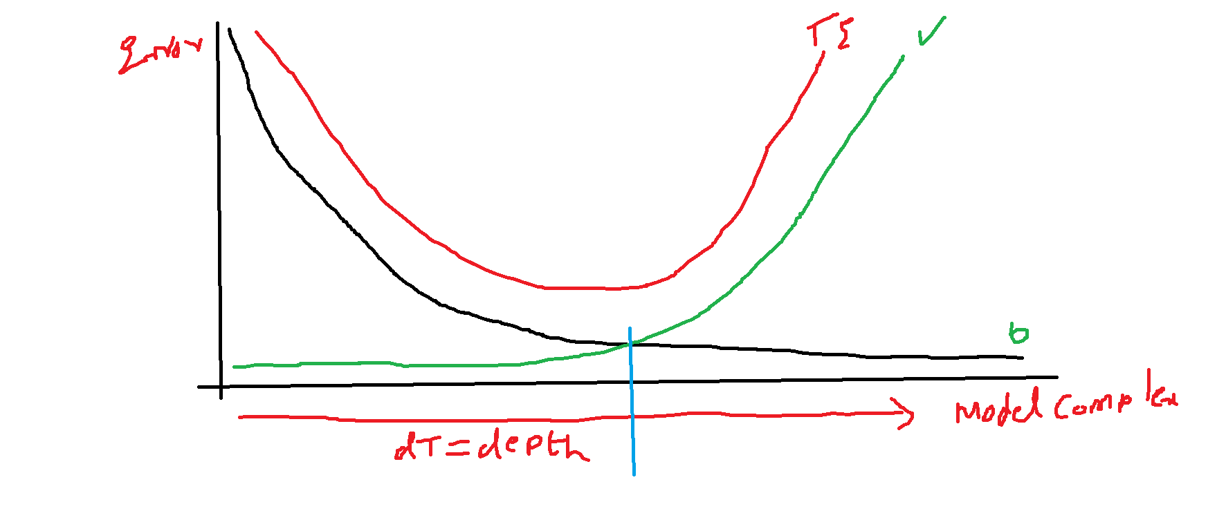

$$As Tree Depth increases , The model Complexity increases$$

$$Less Depth=Under fit$$

$$More Depth=Overfit$$

$$Tree Pruning Two types$$

$Pre pruning$

$Analogy with Regression equation$

$Every time will add a column will chcek the R_{Sq} and Adj_{R}$

$Forward selection method$

$Similary we need to increase the depth of the tree level by level$

$at each level will calculate the Performance of the Model$

$Post Pruning$

$Analogy with Regression equation$

$Add aall column will chcek the R_{Sq} and Adj_{R}by removing each variable$

$Backward selection method$

$Similary let the Tree grown first as much as it can$

$then decrease the Depth level by level$